You’re invited to:

Eta Chi Chapter’s
50th Anniversary Celebration

Sheraton Norfolk Waterside Hotel
Saturday, July 15th, 2017
6:00pm – 12:00am

50th Anniversary Itinerary
Saturday, July 15th- 6:00pm – 7:00pm Check-In for buffet dinner guests ONLY. Cash bar open. Cheese and cracker trays available. (The Promenade, 3rd floor)
7:15pm – 8:30pm Buffet Dinner (Providence/Poplar Ballroom) **Doors to the ballroom will be closed from 6:00pm to 8:30pm to everyone except dinner participants.
8:30pm – 12:00am Ballroom opens to all. **Check-in for after dinner guests.
8:45pm Presentations and Awards
**6:00pm – 12:00am Cash Bar Available for Liquor, Beer, Wine and Soda Options

Providence/Poplar Ballroom Buffet Menu
Starters:
Mixed Garden Greens with Assorted Toppings and Dressings
Tomato and Fresh Mozzarella Salad with Balsamic Drizzle
Entrees:
Pan Seared Salmon Filet with a Light Creamy Dill Sauce
Roasted Sirloin of Beef with a Peppercorn Cognac Cream Sauce
Sides:
Seasonal Mixed Vegetables
Mashed Potatoes
Desserts:
Chef’s Selections of Assorted Desserts

**Warm Rolls and Butter
**Coffee, Tea, and Water Service

General Information

*We would prefer ALL items to be paid for in advance. However, after dinner admissions may be purchased at the door.
*Whether you pay in advance or at the door, RSVP for after dinner admissions is requested, but, not required.
*As in the past, Sigma Nu events are open only to those brothers and alumni in good standing with the chapter. Brothers and Alumni who are not in good standing will not be allowed into the function. (i.e., Expelled, Suspended)
*In addition to brothers and alumni, this event is open to all past sweethearts and Sigma Nu HQ staff.
*Dress Code: Formal attire or coat and tie for gentlemen.
*Room reservations for the Sheraton Norfolk Waterside must be made by June 15, 2017 to get the group rate ($159.00). To book a room, just click on the following link https://www.starwoodmeeting.com/Book/EtaChi50th. The hotel’s information and amenities can be found on this site. They can also be contacted by calling 757-622-6664.
*The Sheraton Norfolk Waterside is located at 777 Waterside Drive, Norfolk, Virginia 23510. It’s located in downtown Norfolk near the foot of Interstate 264 (St. Paul’s Blvd and Waterside Drive) next to the Waterside Complex.
*Music will be provided by Astro Disc Jockeys and a photo booth will also be set up.
*Coffee for the night will be provided by Lynnhaven Coffee Company.
*Additional information about the 50th Anniversary and the Alumni Chapter can be found on our Alumni Chapter website: www.sigmanuhx.com or on our Facebook Group: Sigma Nu Alumni-Eta Chi Chapter.
*RSVP FOR ALL OPTIONS DUE BY JUNE 30, 2017. NO REFUNDS AFTER JUNE 30, 2017.
Should you have any questions or want more information, please feel free to contact us:
Terry Baughker cell: 757-477-9693
Colin Skogstad cell: 757-630-5398
Alumni Chapter Email: sigmanuodualumni@gmail.com

Merchandise
50th Anniversary Polo Shirts
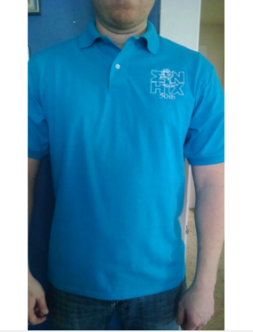
Men’s Jerzees 437 SpotShield Polo in 6 Colors – Sizes: Small-5XL
$25.00 each Colors: California Blue, Black, Royal Blue, Charcoal Gray, Gold, Pink
- Cotton & Polyester
- ULTIMATE COMFORT: You can't get enough of comfortable clothing. It's like you want to wear them all day, every day. So, Jerzees designed their clothes so comfortable that you'll never want to get changed.
- ENVIRONMENTALLY FRIENDLY: Jerzees makes their items with dedication to the environment and sustainability so you don't have to feel any guilt about your style. They believe in making the world a better place, one pant at a time.
- STAY STYLISH: Just because your relaxing, or even when you're working out, doesn't mean you shouldn't look good. These designs are sure to be flattering and complimentary as well as comfortable.
- INCREASED MOBILITY: No one wants their clothes to be limiting whether you're moving or not. Get the apparel that gives you freedom and range where you need it most.
- TRUSTED DURABILITY: Whether you're at the gym or on the couch Jerzees makes clothing that will withstand any activity or no activity. You can trust that your clothes will outlast the competition, just like you.

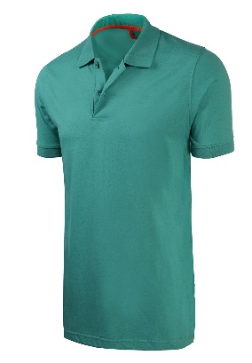
Men’s Marq 75 Slim Fit Jersey Polo in 6 Colors- Ultra Soft Fabric
Sizes: Small- XL
$25.00 each Colors: Black, Coral, Royal Blue, Neon Orange, Navy, Heather Gray
FANTASTICALLY COMFORTABLE. Made from a blend of 60% cotton and 40% polyester, this jersey polo is lightweight, breathable, and super soft—great for wearing throughout the summer or for layering under a jacket or a sweater when the weather is cooler.
- STYLISH SLIM FIT. Inspired by the contemporary shift towards trimmer, more form-flattering looks, this shirt fits closer at the chest and waist than a standard fit, making it an excellent choice for the man for whom the words sleek and modern describe his sense of style.
- LOW MAINTENANCE. Fully machine washable and dryable, this shirt doesn't require a trip to the dry cleaners and isn't going to shrink or self-destruct in the wash, making it as easy to maintain as it is to wear.
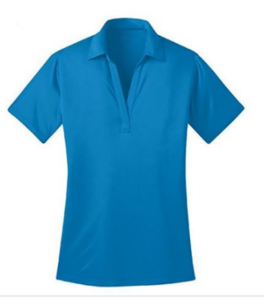

Joe's USA Ladies Silk Touch Golf Polo's in 6 Colors – Sizes: XS-4XL

$30.00 each Colors: Navy, Pink Raspberry, Black, Brilliant Blue, Teal Green, Neon Orange

We took our legendary Silk Touch Polo and made it work even harder. The durable Silk Touch Performance Polo wicks moisture, resists snags and thanks to PosiCharge™ technology, holds onto its color for a professional look that lasts. There’s just no higher performing polo at this price!
- 3.9-ounce, 100% cationic polyester double knit
- Self-fabric collar. Double-needle sleeve cuffs and hem
- 3-button placket with dyed-to-match buttons. Tag-free label. Set in, open cuff sleeves

Other Events
Norfolk Tides Baseball Game / Picnic
Harbor Park
150 Park Ave., Norfolk, Va. 23510
Friday, July 14th
Picnic: 5:30pm-7:00pm Game Starts at 7:05pm
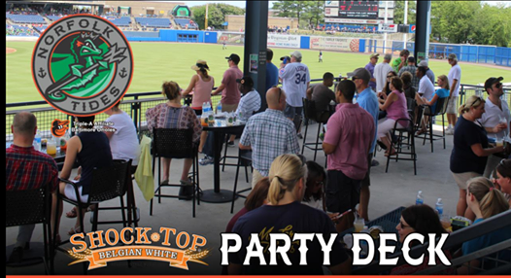
Party Deck Details:
Located just beyond the right field wall.
Covered roof that keeps you out of the sun on hot days and protects you from rain.
Picnic and high-top tables to accommodate your meals.

Menu
Beef Hot Dogs, Pulled Pork BBQ, and Fried Chicken
Also, includes Potato Salad, Potato Chips, Cole Slaw, Cookies, Watermelon, and Assorted Sodas
$32.25 / person includes Picnic and 1 Game Ticket

RSVP and Payment Sheet
Name ____________________________________________
Guest Name _____________________________________
Please write the quantities next to each item that you would like to purchase:
Quantity x Cost = Total
____ Buffet Dinner and Admission……...... $70.00 / Person _____
____ Admission After Dinner…………….... $25.00 / Person in Advance _____
(Admission begins at 8:30 pm) *($30.00 / Person after June 30th or at door)
____ Tickets to the Tides Baseball Game…$32.25 / Person _____
(Includes 1 game ticket and picnic)
____ Men’s Jerzees 437 SpotShield Polo Shirt Sizes: Small – 5XL _____
(Available colors: California Blue, Black, Royal Blue, Charcoal Gray, Gold, Pink)
$25.00 / Shirt Color: __________________________ Size _____
Color: __________________________ Size _____

____ Men’s Marq 75 Slim Fit Jersey Polo Shirt Sizes: Small - XL _____
(Available colors: Black, Coral, Royal Blue, Neon Orange, Navy, Heather Gray)
$25.00 / Shirt Color: ___________________________Size _____
Color: ___________________________Size _____
____ Joe’s USA Ladies Silk Touch Golf Polo Shirt Sizes: XS- 4XL _____
(Available colors: Navy, Pink Raspberry, Black, Brilliant Blue, Teal Green, Neon Orange)
$30.00 / Shirt Color: ___________________________Size _____
Color: ___________________________Size _____
____ Optional Two Color Logo (white and gold stitching) .... $2.00 per Shirt _____
(“50^{th”} and “HX” will be in gold)

Please enter TOTAL AMOUNT DUE for all choices and amounts above $________
To order and pay online, please visit the alumni chapter website at: www.sigmanuhx.com. Otherwise, please make check or money order payable to: Eta Chi Alumni. Dinner reservation(s) will only be accepted if accompanied by payment in advance. Please include this RSVP/Payment Sheet with your payment.
Mail your payment and RSVP SHEET to: Eta Chi Alumni
P.O. Box 14462
Norfolk, Virginia 23518

THE DEADLINE FOR ALL RSVPS AND PAYMENTS IS JUNE 30, 2017
*NO REFUNDS AFTER JUNE 30, 2017

